**Installation/Testing procedures.**

**DRAFT 2**

**Installation:**

1. Create a folder called “ORMAP” on the C drive.
2. Create a sub folder under ORMAP called “MapProduction”.
3. Unzip contents into the MapProduction folder.
4. Copy existing MapProduction map document into the subfolder “MapDocuments” under the new MapProduction folder.

**NOTE: It is recommended that you make a backup copy of your current Map Production map.**

1. Open the MapProduction map document.
2. Open the Catalog Window by clicking on the Catalog Window button.



1. In the Catalog Window expand the “Home” group and you will see the ORMAP Map Production toolbox. Expand the toolbox to display the tools.

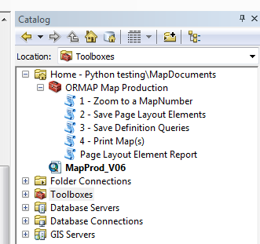

**Configuration:**

Each county has slight variations in the maps they produce. This tool is offered as a base template by which your county can use to produce maps. It should be noted that some customizations will need to be performed to the configuration files and/or the code itself to meet your individual county’s needs. These configuration instructions are a starting point.

1. Run the “Page Layout Element Report” tool to evaluate your current map elements and their current names.
2. Go through each map element in your map document and modify its name to match that displayed in one of the two diagrams (18x20 or 18x24) shown at the bottom of this document. You can change the name of a map element by right-clicking the map element and choosing Properties. Click the “Size and Position” tab and you will see “Element Name” located on the bottom right part of the window. A description of the map elements is as follows:

NOTE: Items denoted in bold are required and the ones in italic are recommended. The others are optional.

* **MainDF* – The main dataframe.**
* *MapNumber* – Not used on the map, however it is used by the code to determine which map you are working with.*
* MainMapTitle* – Map title.
* CountyName† – The County name.
* MainMapScale† – The map scale in the format 1” = x’
* Disclaimer* – The maps disclaimer.
* DisclaimerBox† – A box that surrounds the disclaimer.
* PlotDate* – The auto generated date on the map.
* CanMapNumber* – The cancelled numbers primary column.
* Can MapNumber2† – A second column for cancelled numbers overflow.
* CanMapNumber3† – A third column for cancelled numbers overflow.
* UpperRightMapNum* – The mapnumber listed in the upper right corner of the map.
* LowerRightMapNum* – The mapnumber listed in the lower right corner of the map.
* UpperLeftMapNum‡ – The mapnumber listed in the upper left spot.
* LowerLeftMapNum‡ – The mapnumber listed in the lower left spot.
* LocatorDF – The locator data frame.
* SectionsDF – The Sections data frame.
* QSectionsDF – The Quarter Sections data frame.
* smallMapTitle‡ – A smaller version of the MainMapTitle.
* smallMapScale‡ – A smaller version of the MainMapScale.
* NorthArrow* – The North arrow.
* ScaleBar* – The scalebar.

* These items have their x/y coordinates stored in the PageLayoutElements table.

† These items x/y coordinates derived from other page elements. These may include offsets described in the configuration files.

‡ These items x/y coordinates are not stored or calculated however the text value is repeated from another page element.

1. Navigate to the Scripts folder (C:\ORMAP\MapProdcution\Scripts) and modify (copy the information from your original ini file) the ORMAP_18x20MapConfig.py and/or ORMAP_18x24MapConfig.py files as well as the ORMAP_LayersConfig.py files. Note that there are a few new items in these “Config” files that were not in your ini files.
2. Test the Zoom To MapNumber.
3. Test the Print
4. Test the other tools.

**Diagram for 18x20 map**: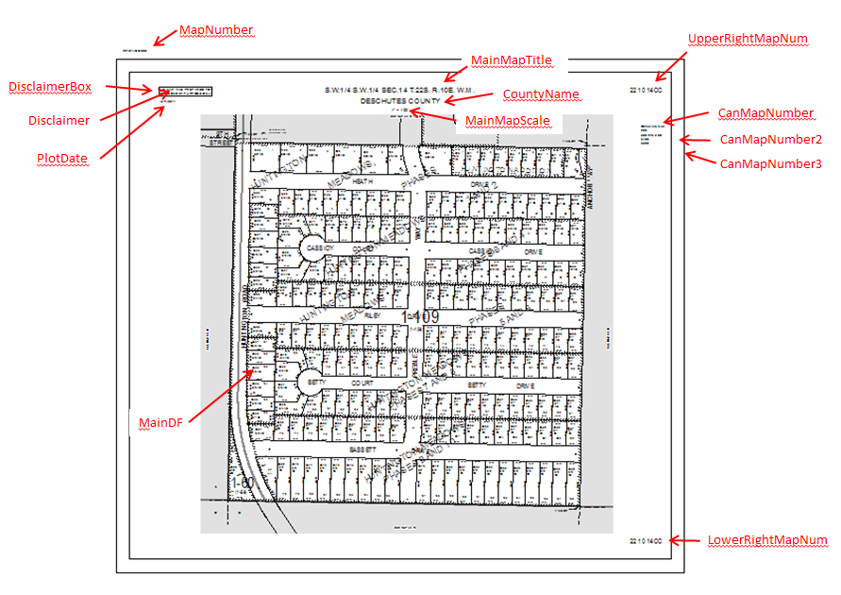

**Diagram for 18x24 map**: 